**Configure the Launch Schedules**

This article has been updated to support v4.1 of Goliath Application Availability Monitor.

**Article Contents**

* [Prerequisites](https://support.goliathtechnologies.com/hc/en-us/articles/360025158873-Configure-the-Launch-Schedules#h_c2d56371-52fc-49c4-94a6-76456f0272af)
* [Creating a Launch](https://support.goliathtechnologies.com/hc/en-us/articles/360025158873-Configure-the-Launch-Schedules#h_f9233049-47d6-4b74-a8d6-80860f569451)
  + [Citrix Virtual Apps & Desktops](https://support.goliathtechnologies.com/hc/en-us/articles/360025158873-Configure-the-Launch-Schedules#h_5de6c579-0223-424c-8d4f-431a98bde9d4)
  + [Citrix DaaS (Cloud)](https://support.goliathtechnologies.com/hc/en-us/articles/360025158873-Configure-the-Launch-Schedules#h_01GG8A1ZKEXG9XV5VS8H9GKC4F)
  + [VMware Horizon](https://support.goliathtechnologies.com/hc/en-us/articles/360025158873-Configure-the-Launch-Schedules#h_c902d67d-db4a-486a-808c-ef83da2b4e32)
  + [Microsoft RDS](https://support.goliathtechnologies.com/hc/en-us/articles/360025158873-Configure-the-Launch-Schedules#h_d51fbc02-301c-4c02-af68-83967dd15c10)
  + [Cerner Patient Portal](https://support.goliathtechnologies.com/hc/en-us/articles/360025158873-Configure-the-Launch-Schedules#h_6f8cc5f4-4e58-4fa3-8347-6ecf949accdc)
* [Testing a Launch](https://support.goliathtechnologies.com/hc/en-us/articles/360025158873-Configure-the-Launch-Schedules#h_7ee4899a-d328-44d5-8bb2-a9d19a3a82b1)
* [Launch Scheduling](https://support.goliathtechnologies.com/hc/en-us/articles/360025158873-Configure-the-Launch-Schedules#h_4c2d4417-0018-4904-9310-a9011a0f40b5)
* [Post Configuration: What's Next?](https://support.goliathtechnologies.com/hc/en-us/articles/360025158873-Configure-the-Launch-Schedules#h_ef4554d1-e30a-4d00-a3da-b8a082ee3226)

**Prerequisites**

Before proceeding, please make sure that the appropriate [Launch Endpoint has been configured](https://support.goliathtechnologies.com/hc/en-us/articles/360024769993).

**Creating a Launch**

Now that the prerequisites are taken care of, in this section we will create the launch conditions, test the launches and cover some common troubleshooting steps. Please note, it is important to do a manual launch of the applications/desktops on the Launch Endpoint as you are configuring the launches to verify all settings and bypass any prompts.

**Citrix Virtual Apps & Desktops**

* Open the Goliath console
* Navigate to the **Application Availability** tab and then choose **Schedule**
* Click **New** at the bottom of the page and a pane will appear with multiple tabs at the top
  + 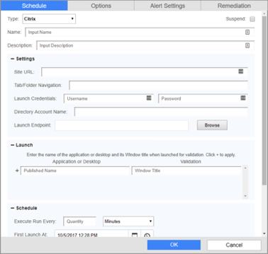
* Starting with the default **Schedule** tab, please enter the appropriate data for each field:

|  |  |
| --- | --- |
| **Field Name** | **Description** |
| **Type** | Citrix is configured out of the box. There is no need to change this field unless advised by a Goliath engineer. |
| **Name** | The unique name to identify the launch |
| **Description** | Description of the launch |
| **Site URL** | The URL of your Citrix Portal (Storefront, Web Interface, NetScaler Gateway), including **HTTP** or **HTTPS**. Please ensure that this URL was added to trusted sites with the security set to low prior to scheduling. |
| **Tab/Folder Navigation**  *(optional)* | If the app/desktops reside in a tab and or folder that is not the default page once the user logs in, please define the path to the Application and or Desktop.  For example, if your Citrix Storefront has the “Apps” and “Desktops” tabs at the bottom or top of the page, you will need to enter which tab the item is under. Also, folders can be separated by ‘/’ if there are any nested folders; i.e. 'Apps/Browsers'. Similarly, 'Apps/Categories/Office Apps'. |
| **Launch Credentials** | Citrix Portal credentials for GAAM service account. These must be entered the same exact way they will be entered into the Citrix Portal. |
| **Launch Endpoint** | The machine in which the launches will be executing |
| **Application or Desktop & Validation** | Enter the information for the Applications and or Desktops that you would like to launch in the ‘Application or Desktop’ field and then the Window Title in the ‘Validation’ field. Click the ‘+’ symbol to complete the add and repeat the above for each app/desktop. **Please Note:**   * Application and Desktop must be entered the exactly as they appear on the Citrix site but are not case sensitive. * The window title only needs to be a partial match. If the application does not have a window title, one does not need to be defined. * If your window titles often change, the Boolean character of ‘+’ is accepted. * GAAM will launch the apps/desktops in the order in which you define them. * If you have an application with a windows logon Eula/disclaimer, you can use the ‘>’ character to separate the 2 window titles (the win logon page and the actual application window). * he applications/desktops defined in a given launch must reside in the same location on the Citrix site (i.e. folder/tab) |
| **Execute Run Every** | Frequency in which the launch will execute. It is important to make sure that your scheduled launches have the appropriate time to execute and logoff properly before another one begins.  Once this launch is saved Goliath with display the maximum launch time and will display any launch conflicts. The maximum simulation time is the amount of time the simulation would take to execute if all the apps/desktops configured were to fail. |
| **First Launch At** | Define the Date & Time in which the first launch will execute. Future launches will execute based on the ‘run every’ schedule defined above |
| **Launch Duration**  *(optional)* | To alert on the launch duration of an app/desktop, the time from app click to GAAM identified successful, enter the threshold. |
| **Severity**  *(optional)* | Criticality ranking |
| **Alert 1st time after**  *(optional)* | To alert have multiple failures, instead of the first, enter the number in which the alert should be sent. I.E., 2 failures in a row. |
| **Notify on Restore**  *(optional)* | Check the box to receive an alert notification when a launch changes from a failed state to a success state. |

On the **Options** tab, the following settings can be applied if applicable:

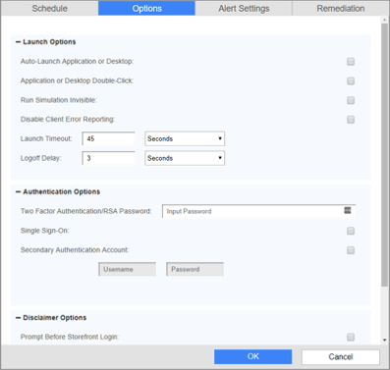

|  |  |
| --- | --- |
| **Field Name** | **Description** |
| **Auto-Launch Application or Desktop**  *(optional)* | Check this box if your environment auto-launches an app/desktop at logon. If this box is selected, it will apply to all applications/desktops defined in the simulation rule. If it is not applicable to some of the applications/desktops defined, please remove those from the simulation and create a separate one. |
| **Application or Desktop Double-Click**  *(optional)* | Check this box if you would like the Logon Simulator to click on the application/desktop a second time if there was no confirmation on the resources launching |
| **Run Simulation Invisible**  *(optional)* | Check this box if you do not the simulation windows to visibly appear on the screen |
| **Disable Client Error Reporting**  *(optional)* | By default, the Logon Simulator is going to look for any Citrix Receiver errors on the Launch Endpoint. Please select this option if you would NOT like the Logon Simulator to look for these error events. |
| **Launch Timeout** | This is the threshold for whether or not the simulation is a success or failure. If any stage of the simulation process exceeds this threshold the simulation will report back as failed. |
| **Logoff Delay** | Once the simulation has been deemed a success, the session will delay to logoff after the defined number plus 60 seconds. Therefore, if you’d like to keep the session open for 2 minutes, you’d input 60 into this field. |
| **Two Factor Authentication/ RSA Password**  *(optional)* | If multi-factor authentication is used, please enter the static token in this field. Please note, if this is your configuration, we suggest contacting the Goliath Support team as some customer specific modifications may be needed. |
| **Single Sign-On**  *(optional)* | Check this box if single sign-on is enabled in your environment. |
| **Secondary Authentication Account**  *(optional)* | If your environment uses 2-factor authentication, please enter your credentials here. Please note, if this is your configuration, we suggest contacting the Goliath Support team as some customer specific modifications may be needed. |
| **Prompt Before Storefront Login**  *(optional)* | Check this box if you have a Eula/disclaimer prompt appear before signing into the Storefront page |
| **Prompt After Storefront Login**  *(optional)* | Check this box if you have a Eula/disclaimer prompt appear after signing into the Storefront page |
| **After Application or Desktop Launch**  *(optional)* | Check this box if you have a Eula/disclaimer prompt appear inside your desktop or applications. Please note, this setting requires an active windows session and will not work if the user is disconnected. |
| **Detect Receiver Before Login**  *(optional)* | Check this box if you have a "Detect Receiver" button appear on your storefront/netscaler gateway prior to being able to sign in |
| **Detect Receiver After Login**  *(optional)* | Check this box if you have a "Detect Receiver" button appear on your storefront/netscaler gateway after authenticating |

**Citrix DaaS (Cloud)**

* Open the Goliath console
* Navigate to the **Application Availability** tab and then choose **Schedule**
* Click **New** at the bottom of the page and a pane will appear with multiple tabs at the top
  + 
* Starting with the default **Schedule** tab, please enter the appropriate data for each field:

|  |  |
| --- | --- |
| **Field Name** | **Description** |
| **Type** | Citrix is configured out of the box. Use the drop-down menu to select the option for ‘Citrix Cloud’ |
| **Name** | The unique name to identify the launch |
| **Description** | Description of the launch |
| **Site URL** | The URL of your Citrix DaaS Portal (Storefront/Gateway). Please ensure that this URL was added to trusted sites with the security set to low prior to scheduling. |
| **Tab/Folder Navigation**  *(optional)* | If the app/desktops reside in a tab and or folder that is not the default page once the user logs in, please define the path to the Application and or Desktop.  For example, if your Citrix Storefront has the “Apps” and “Desktops” sections on the left hand pane of the page, you will need to enter which tab the item is under. Also, menu selections can be separated by ‘/’ ; i.e. 'Apps/Favorites'. Similarly, 'Apps/All Apps'. |
| **Launch Credentials** | Citrix Portal credentials for GAAM service account. These must be entered the same exact way they will be entered into the Citrix Portal. |
| **Launch Endpoint** | The machine in which the launches will be executing |
| **Application or Desktop & Validation** | Enter the information for the Applications and or Desktops that you would like to launch in the ‘Application or Desktop’ field and then the Window Title in the ‘Validation’ field. Click the ‘+’ symbol to complete the add and repeat the above for each app/desktop. **Please Note:**   * Application and Desktop must be entered the exactly as they appear on the Citrix site but are not case sensitive. * The window title only needs to be a partial match. If the application does not have a window title, one does not need to be defined. * If your window titles often change, the Boolean character of ‘+’ is accepted. * GAAM will launch the apps/desktops in the order in which you define them. * If you have an application with a windows logon Eula/disclaimer, you can use the ‘>’ character to separate the 2 window titles (the win logon page and the actual application window). * he applications/desktops defined in a given launch must reside in the same location on the Citrix site (i.e. folder/tab) |
| **Execute Run Every** | Frequency in which the launch will execute. It is important to make sure that your scheduled launches have the appropriate time to execute and logoff properly before another one begins.  Once this launch is saved Goliath with display the maximum launch time and will display any launch conflicts. The maximum simulation time is the amount of time the simulation would take to execute if all the apps/desktops configured were to fail. |
| **First Launch At** | Define the Date & Time in which the first launch will execute. Future launches will execute based on the ‘run every’ schedule defined above |
| **Launch Duration**  *(optional)* | To alert on the launch duration of an app/desktop, the time from app click to GAAM identified successful, enter the threshold. |
| **Severity**  *(optional)* | Criticality ranking |
| **Alert 1st time after**  *(optional)* | To alert have multiple failures, instead of the first, enter the number in which the alert should be sent. I.E., 2 failures in a row. |
| **Notify on Restore**  *(optional)* | Check the box to receive an alert notification when a launch changes from a failed state to a success state. |

On the **Options** tab, the following settings can be applied if applicable:



|  |  |
| --- | --- |
| **Field Name** | **Description** |
| **Auto-Launch Application or Desktop**  *(optional)* | Check this box if your environment auto-launches an app/desktop at logon. If this box is selected, it will apply to all applications/desktops defined in the simulation rule. If it is not applicable to some of the applications/desktops defined, please remove those from the simulation and create a separate one. |
| **Application or Desktop Double-Click**  *(optional)* | Check this box if you would like the Logon Simulator to click on the application/desktop a second time if there was no confirmation on the resources launching |
| **Run Simulation Invisible**  *(optional)* | Check this box if you do not the simulation windows to visibly appear on the screen |
| **Disable Client Error Reporting**  *(optional)* | By default, the Logon Simulator is going to look for any Citrix Receiver errors on the Launch Endpoint. Please select this option if you would NOT like the Logon Simulator to look for these error events. |
| **Launch Timeout** | This is the threshold for whether or not the simulation is a success or failure. If any stage of the simulation process exceeds this threshold the simulation will report back as failed. |
| **Logoff Delay** | Once the simulation has been deemed a success, the session will delay to logoff after the defined number plus 60 seconds. Therefore, if you’d like to keep the session open for 2 minutes, you’d input 60 into this field. |
| **Two Factor Authentication/ RSA Password**  *(optional)* | If multi-factor authentication is used, please enter the static token in this field. Please note, if this is your configuration, we suggest contacting the Goliath Support team as some customer specific modifications may be needed. |
| **Single Sign-On**  *(optional)* | Check this box if single sign-on is enabled in your environment. |
| **Secondary Authentication Account**  *(optional)* | If your environment uses 2-factor authentication, please enter your credentials here. Please note, if this is your configuration, we suggest contacting the Goliath Support team as some customer specific modifications may be needed. |
| **Prompt Before Storefront Login**  *(optional)* | Check this box if you have a Eula/disclaimer prompt appear before signing into the Storefront page |
| **Prompt After Storefront Login**  *(optional)* | Check this box if you have a Eula/disclaimer prompt appear after signing into the Storefront page |
| **After Application or Desktop Launch**  *(optional)* | Check this box if you have a Eula/disclaimer prompt appear inside your desktop or applications. Please note, this setting requires an active windows session and will not work if the user is disconnected. |
| **Detect Receiver Before Login**  *(optional)* | Check this box if you have a "Detect Receiver" button appear on your storefront/netscaler gateway prior to being able to sign in |
| **Detect Receiver After Login**  *(optional)* | Check this box if you have a "Detect Receiver" button appear on your storefront/netscaler gateway after authenticating |

**VMware Horizon**

* Open the Goliath console
* Navigate to the **Application Availability** tab and then choose **Schedule**
* Click **New** at the bottom of the page and a pane will appear with multiple tabs at the top
* Starting with the default **Schedule** tab, please enter the appropriate data for each field:

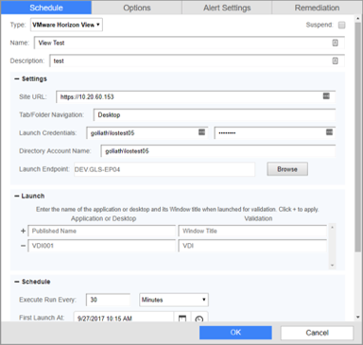

|  |  |
| --- | --- |
| **Field Name** | **Description** |
| **Type** | Citrix is configured out of the box. Use the drop-down menu to select the option for ‘VMware Horizon View’ |
| **Name** | The unique name to identify the launch |
| **Description** | Description of the launch |
| **Site URL** | The URL of your Connection Server Portal |
| **Tab/Folder Navigation** | If you will be launching a desktop, please enter the word “**Desktop**” case sensitive without the quotes in this field. If you are launching an application you can leave it blank. |
| **Launch Credentials** | VMware View credentials for the GAAM test service account. Please make sure to define the username as **domain\user**. |
| **Directory Account Name** | Please copy the VMware View username into this field. |
| **Launch Endpoint** | The machine in which the launches will be executing |
| **Application or Desktop & Validation** | * Enter the information for the Applications and or Desktops that you would like to launch in the ‘Application or Desktop’ field and then the Window Title in the ‘Validation’ field. Click the ‘+’ symbol to complete the add.**Please Note:** * Application and Desktop must be entered the exactly as they appear on the VMware site but are not case sensitive. * The window title only needs to be a partial match. If the application does not have a window title, one does not need to be defined. * f your window titles often change, the Boolean character of ‘+’ is accepted. * If you have an application with a windows logon Eula/disclaimer, you can use the ‘>’ character to separate the 2 window titles (the win logon page and the actual application window). * **Only one application/desktop can be launched per configuration**. |
| **Execute Run Every** | Frequency in which the launch will execute. It is important to make sure that your scheduled launches have the appropriate time to execute and logoff properly before another one begins.  Once this launch is saved Goliath with display the maximum launch time and will display any launch conflicts. The maximum simulation time is the amount of time the simulation would take to execute if all the apps/desktops configured were to fail. |
| **First Launch At** | Define the Date & Time in which the first launch will execute. Future launches will execute based on the ‘run every’ schedule defined above |
| **Launch Duration**  *(optional)* | To alert on the launch duration of an app/desktop, the time from app click to GAAM identified successful, enter the threshold. |
| **Severity**  *(optional)* | Criticality ranking |
| **Alert 1st time after**  *(optional)* | To alert have multiple failures, instead of the first, enter the number in which the alert should be sent. I.E., 2 failures in a row. |
| **Notify on Restore**  *(optional)* | Check the box to receive an alert notification when a launch changes from a failed state to a success state. |

* On the **Options** tab, the following settings can be applied if applicable:

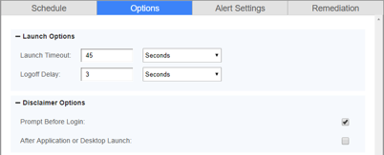

|  |  |
| --- | --- |
| **Field Name** | **Description** |
| **Launch Timeout** | This is the threshold for whether or not the launch is a success or failure. If any stage of the launch process exceeds this threshold the simulation will report back as failed. |
| **Logoff Delay** | Once the launch has been deemed a success, the session will delay to logoff after the defined number plus 60 seconds. Therefore, if you’d like to keep the session open for 2 minutes, you’d input 60 into this field. |
| **Prompt Before Login** | Check this box if you have a Disclaimer prompt appear before signing into VMware. |
| **After Application or Desktop Launch** | Check this box if you have a Eula/disclaimer prompt appear inside your desktop or applications. Please note, this setting requires an active windows session and will not work if the user is disconnected. |

**Microsoft RDS**

* Open the Goliath console
* Navigate to the **Application Availability** tab and then choose **Schedule**
* Click **New** at the bottom of the page and a pane will appear with multiple tabs at the top
  + 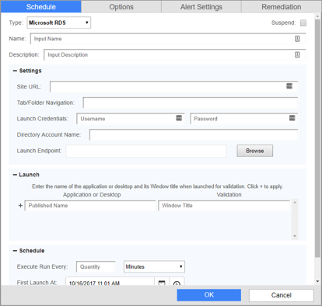
* Starting with the default **Schedule** tab, please enter the appropriate data for each field:

|  |  |
| --- | --- |
| **Field Name** | **Description** |
| **Type** | Use the drop-down menu and select the option for  ‘Microsoft RDS’ |
| **Name** | The unique name to identify the launch |
| **Description** | Description of the launch |
| **Site URL** | The URL of your RDS Web Access |
| **Tab/Folder Navigation**  *(optional)* | If the app/desktops reside in a tab and or folder that is not the default page once the user logs in, please define the path to the Application and or Desktop. |
| **Launch Credentials** | Microsoft RDS credentials for GAAM service account. These must be entered the same exact way they will be entered into the Web Access site |
| **Directory Account Name** | Enter the Microsoft RDS username in the format of DOMAIN\username. |
| **Launch Endpoint** | The machine in which the launches will be executing |
| **Application or Desktop & Validation** | Enter the information for the Applications and or Desktops that you would like to launch in the ‘Application or Desktop’ field and then the Window Title in the ‘Validation’ field. Click the ‘+’ symbol to complete the add and repeat the above for each app/desktop. **Please Note:**   * Application and Desktop must be entered the exactly as they appear on the Web Access site but are not case sensitive. * The window title only needs to be a partial match. If the application does not have a window title, one does not need to be defined. * GAAM will launch the apps/desktops in the order in which you define them. * The applications/desktops defined in a given launch must reside in the same location on the Web Access site (i.e. folder/tab) |
| **Execute Run Every** | Frequency in which the launch will execute. It is important to make sure that your scheduled launches have the appropriate time to execute and logoff properly before another one begins.  Once this launch is saved Goliath with display the maximum launch time and will display any launch conflicts. The maximum simulation time is the amount of time the simulation would take to execute if all the apps/desktops configured were to fail. |
| **First Launch At** | Define the Date & Time in which the first launch will execute. Future launches will execute based on the ‘run every’ schedule defined above |
| **Launch Duration**  *(optional)* | To alert on the launch duration of an app/desktop, the time from app click to GAAM identified successful, enter the threshold. |
| **Severity**  *(optional)* | Criticality ranking |
| **Alert 1st time after**  *(optional)* | To alert have multiple failures, instead of the first, enter the number in which the alert should be sent. I.E., 2 failures in a row. |
| **Notify on Restore**  *(optional)* | Check the box to receive an alert notification when a launch changes from a failed state to a success state. |

On the **Options** tab, the following settings can be applied if applicable:



|  |  |
| --- | --- |
| **Field Name** | **Description** |
| **Launch Timeout** | This is the threshold for whether or not the simulation is a success or failure. If any stage of the simulation process exceeds this threshold the simulation will report back as failed. |
| **Logoff Delay** | Once the simulation has been deemed a success, the session will delay to logoff after the defined number plus 60 seconds. Therefore, if you’d like to keep the session open for 2 minutes, you’d input 60 into this field. |
| **Two Factor Authentication/ RSA Password**  *(optional)* | If multifactor authentication is used, please enter the static token in this field. Please note, if this is your configuration we suggest contacting the Goliath Support team as some customer specific modifications may be needed. |

**Cerner Patient Portal**

* Open the Goliath console
* Navigate to the **Application Availability** tab and then choose **Schedule**
* Click **New** at the bottom of the page and a pane will appear with multiple tabs at the top
* Starting with the default **Schedule** tab, please enter the appropriate data for each field:

|  |  |
| --- | --- |
| **Field Name** | **Description** |
| **Type** | Citrix is configured out of the box. Choose the dropdown menu and select the option for ‘other’. A text box will appear to the right, enter **CernerPatientPortal** |
| **Name** | The unique name to identify the launch |
| **Description**  *(optional)* | Description of the launch |
| **Site URL** | The URL of the Patient Portal |
| **Tab/Folder Navigation**  *(optional)* | Enter the launch users full name, then ‘/’, followed by one allergy assigned to the user.    For example: “Jane Doe/sulfa drugs” |
| **Launch Credentials** | Cerner Patient credentials for GAAM service account. These must be entered the same exact way they will be entered into the web. |
| **Directory Account Name** | Reenter the username of the service account |
| **Launch Endpoint** | The machine in which the launches will be executing |
| **Application or Desktop & Validation** | Enter the name of the launch that you would like to see on the dashboard. For example, “Patient Portal – Central Prod”. |
| **Execute Run Every** | Frequency in which the launch will execute. It is important to make sure that your scheduled launches have the appropriate time to execute and logoff properly before another one begins.  Once this launch is saved Goliath with display the maximum launch time and will display any launch conflicts. The maximum simulation time is the amount of time the simulation would take to execute if all the apps/desktops configured were to fail. |
| **First Launch At** | Define the Date & Time in which the first launch will execute. Future launches will execute based on the ‘run every’ schedule defined above |
| **Launch Duration**  *(optional)* | To alert on the launch duration of an app/desktop, the time from app click to GAAM identified successful, enter the threshold. |
| **Severity**  *(optional)* | Criticality ranking |
| **Alert 1st time after**  *(optional)* | To alert have multiple failures, instead of the first, enter the number in which the alert should be sent. I.E., 2 failures in a row. |
| **Notify on Restore**  *(optional)* | Check the box to receive an alert notification when a launch changes from a failed state to a success state. |

On the ‘**Options’** tab, the following settings can be applied if applicable:

|  |  |
| --- | --- |
| **Field Name** | **Description** |
| **Launch Timeout** | This is the threshold for whether or not the simulation is a success or failure. If any stage of the simulation process exceeds this threshold the simulation will report back as failed. |
| **Logoff Delay** | Once the simulation has been deemed a success, the session will delay to logoff after the defined number plus 60 seconds. Therefore, if you’d like to keep the session open for 2 minutes, you’d input 60 into this field. |

**Test the Launch**

We suggest scheduling a launch to run right away and watching it take place the first time through. This is to validate that the launch is configured properly and to also make sure that nothing interrupts the Application Availability Monitor. Once this has been done one can go back in and configure its normal launch sequence/frequency. Common examples are:

* installation prompt for the Citrix receiver the first time the test user tries to log in
* prompt to download the ICA file
* Incorrect application name or window title

**Launch Scheduling**

Launch Scheduling is a key part in ensuring that the launches will be successful. There are 2 main factors to follow for scheduling:

* There can’t be more than one launch running on the same launch endpoint at the same time.
* The launch user account can’t be running on more than one launch endpoint at the same time.

The technology has built in assistance to help one determine if condition #1 is going to happen. When a launch is created, Goliath uses an algorithm to determine the maximum amount of time that it would take the launch to execute (max run time). This is maximum run time is the time from launch start to finish if there was a failure for all apps/desktops within the launch. The algorithm takes into consideration:

* The number of apps/desktops being launched
* The launch timeout threshold
* The Web logoff delay

Once a new launch is created and saved, on the ‘Schedule’ page one will see the launch details at the bottom of the page. With the launch details, there is a column names ‘Status’. The status column will have a green check box if the launch has no conflicts with another previously scheduled launch. However, if a conflict is going to occurring, the status icon will change to a red ‘X’ for the multiple launches that will be affected. Please note, suspended launches are still taken into consideration.

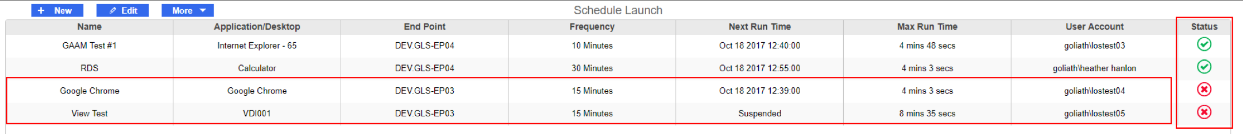

In addition to the launch schedule status showing a red status icon, the grid at the top of the schedule page will also change from blue to red.

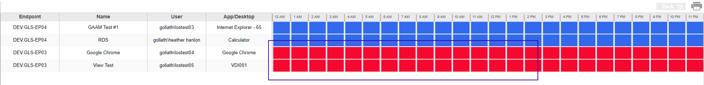

The purpose of the grid at the top of the schedule page is to assist one with resolving a launch conflict. The grid at the top of the page is displaying a 24-hour time line. The boxes that change from blue to red are indicating that there is a conflict within that hour time period. If you click on one of the boxes, it will drill down into a 1-hour period which will display the exact time line.



Looking at the above screenshot, one can see that ‘Google Chrome’ is launch every 15 mins and has a duration of 4 mins and 3 seconds, where ‘VDI001’ is also launch every 15 mins, but has a duration of 8 mins and 35 seconds. One can also visibility identify that they conflict from 3:09- 3:13. To resolve the conflict, one should change the start of the Google Chrome launch from the 9-minute hour mark to the top of the hour, where there is an opening. In making that adjustment the launches now look like this and no longer overlap:

Also, if one hovers over the boxes on the grid a tooltip will appear that display the start and end time of the launch.

**Post Configuration: What's Next?**

Now that a launch has been scheduled, here are some additional articles that can help you.

[Configure Alert Notifications](https://support.goliathtechnologies.com/hc/en-us/articles/360024495814)

[Understanding the Launch Results](https://support.goliathtechnologies.com/hc/en-us/articles/360024496374)

[Scheduled & On Demand Reports](https://support.goliathtechnologies.com/hc/en-us/articles/360024498514)